# CS 255 System Design Document Template

## UML Diagrams

### UML Use Case Diagram

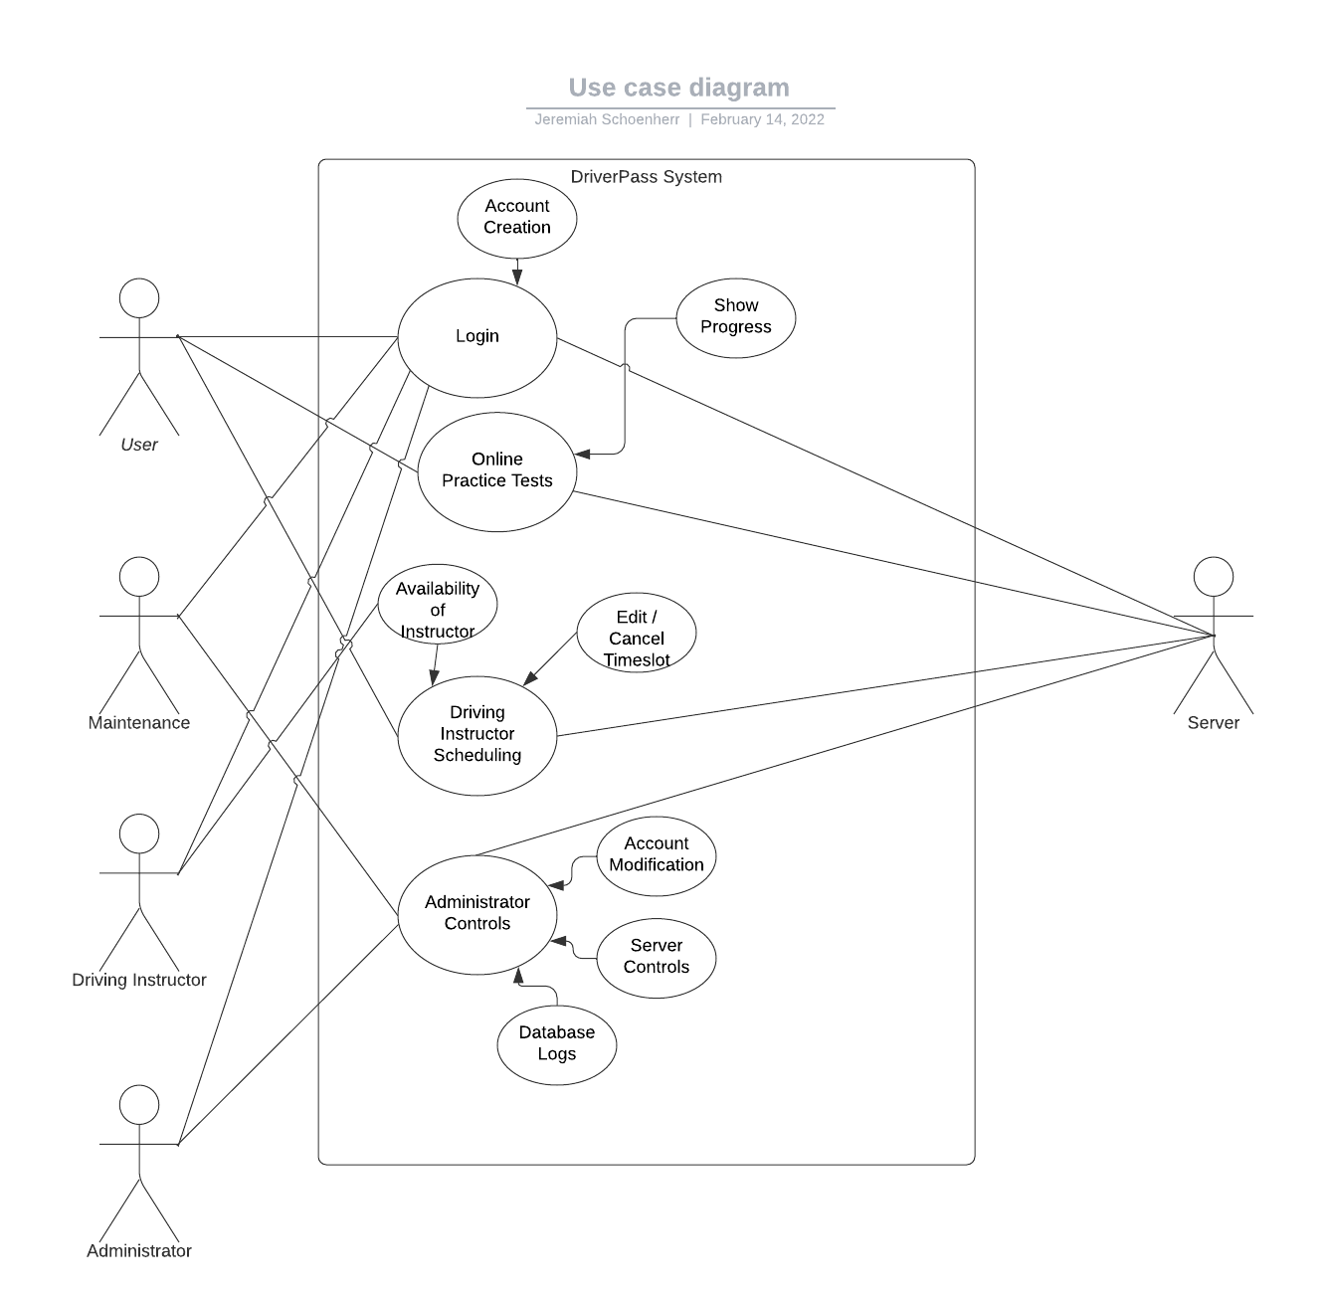

### UML Activity Diagrams

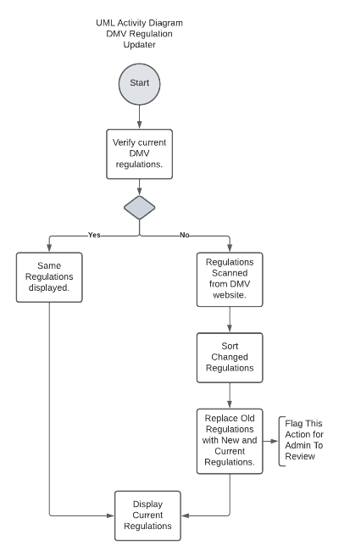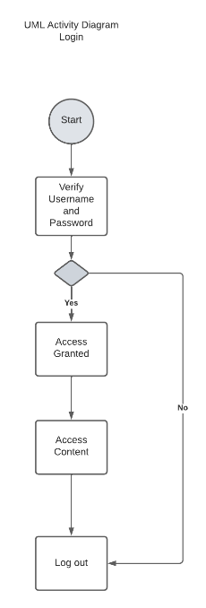

### UML Sequence Diagram

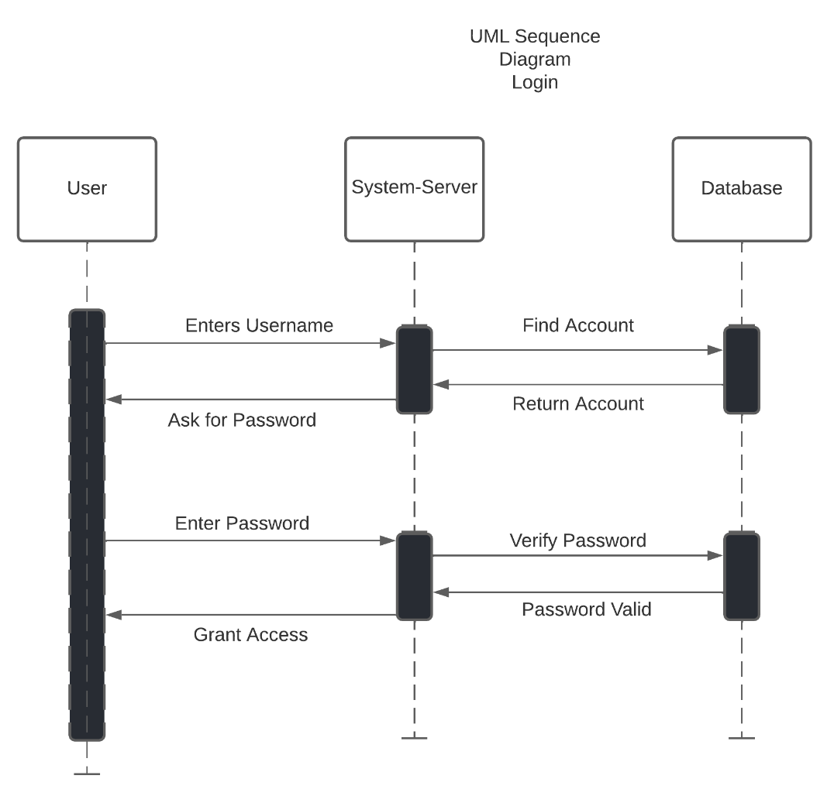

### UML Class Diagram

## Technical Requirements

The DriverPass system will require some technical things such as a host server. Other requirements would include a security service, database system, task runner, and a version control system. Due to the development time-line most of these requirements will be purchased or rented as a service and will have an on-going cost associated with them. Some software may also be required for development, some requiring licenses while others don’t; however the free tools usually have a learning curve associated with them.